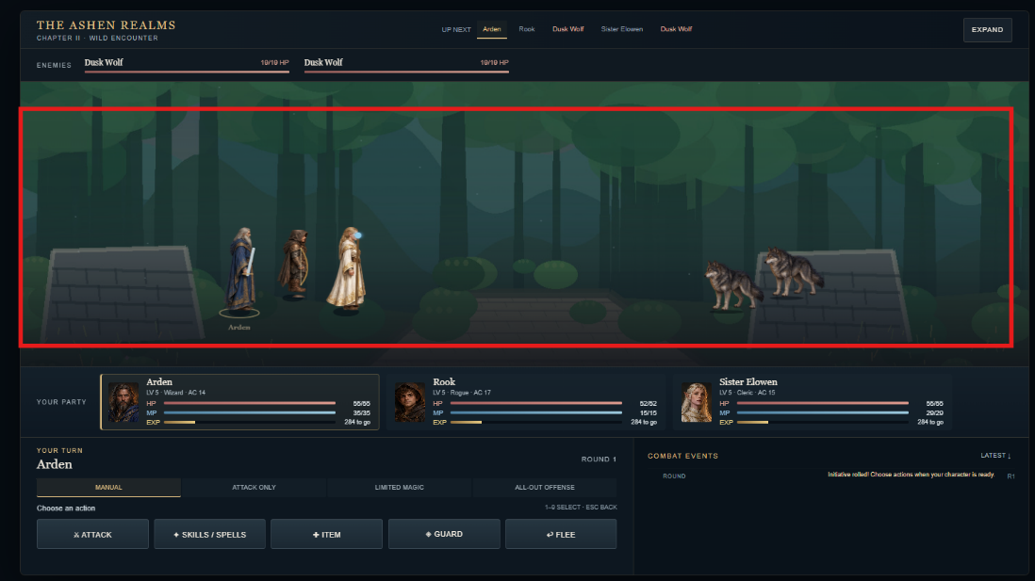
The wilderness background in the battle scenes needs dramatically improved to reflect a realistic wilderness.
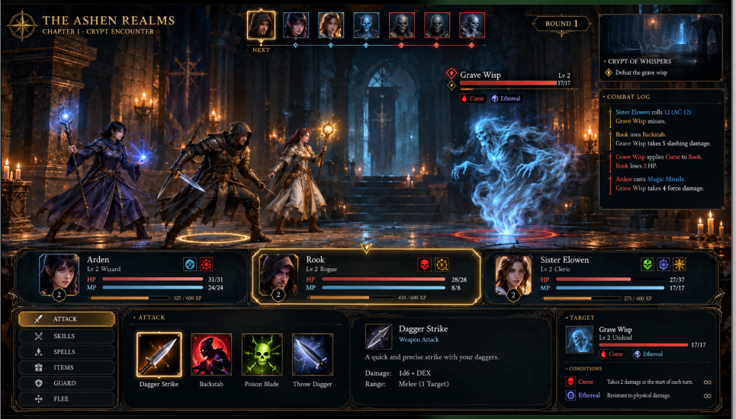
Also the battle UI needs an upgrade. Battle order should count for something. Stronger characters in the front and weaker in the back.

Example Forest background for the battles
